Ideation Phase
Brainstorm & Idea Prioritization Template

Date | 4 march 2026
Member Names | Anushka Madihali, Anuja Chavan,  Pranav Sutar,Shrivardhan Patil
Project Name | Heart disease analysis
Maximum Marks | 4 Marks

Step-1: Team Gathering, Collaboration and Select the Problem Statement

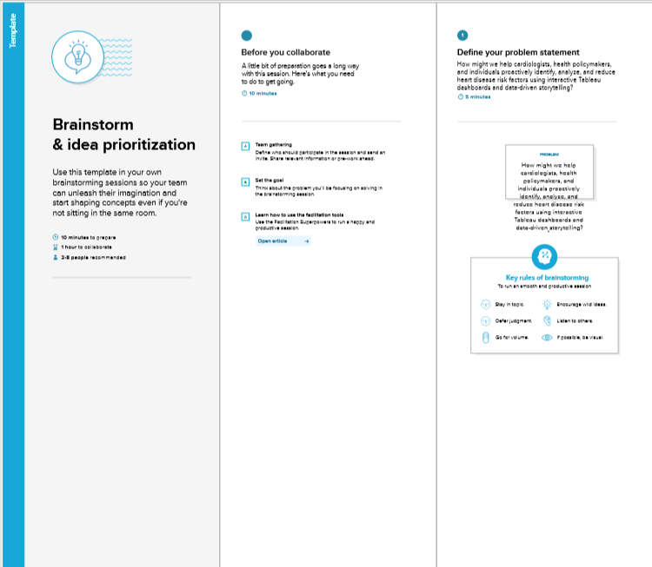

Step-2: Brainstorm, Idea Listing and Grouping
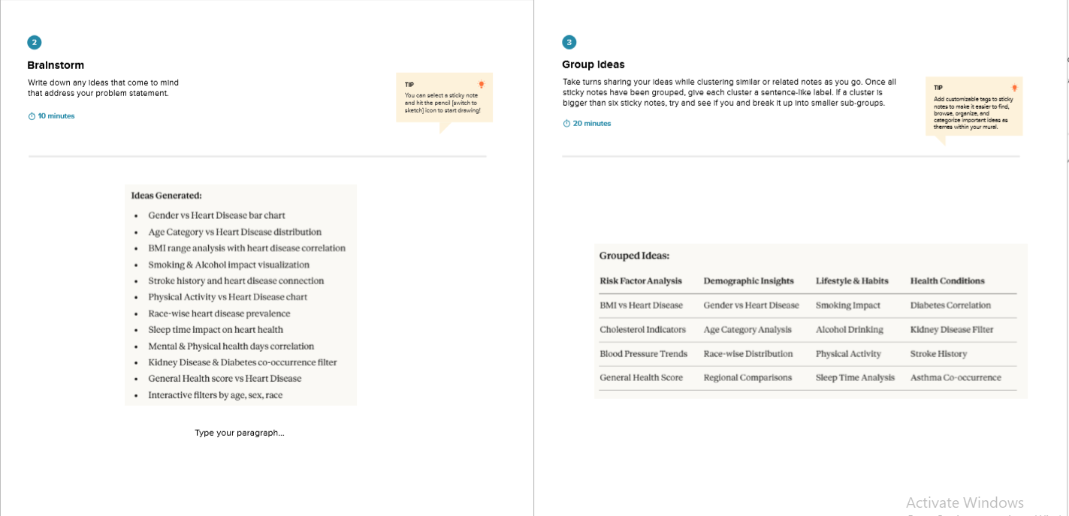

Step-3: Idea Prioritization
